**Landscape Analysis of San Diego Neighborhoods: Identifying the Optimal Location for a New Mexican Restaurant**

**By Fabio Villagran-Gonzalez**

**February 11, 2021**

# **Introduction**

My hometown of San Diego, CA is one of the top ten most populous US cities, housing roughly 1.5 million people. Due to its Spanish and Mexican historical roots and proximity to the US/Mexico border, there is a large Hispanic population in the city, predominantly from Mexico. Additionally, a large number of workers cross over from Tijuana and back each day to work at their jobs in the US, and often need somewhere to stop and grab lunch.

Anywhere you drive around there seem to be an abundance of Mexican eateries, many of which are family-owned and well-known to San Diegans. However, it seems there are go-to neighborhoods around the city that are known for having the best Mexican food, and some neighborhoods with little to no options.

This analysis will explore the neighborhoods around San Diego to determine identifying characteristics of each. These characteristics will be used identify the optimal neighborhoods in San Diego in which an aspiring entrepreneur should open a new Mexican restaurant, in what is a seemingly saturated marketplace with a large total addressable market.

# **Data**

Demographic data broken down by neighborhood was obtained from the City of San Diego’s Data Portal (<https://data.sandiegocounty.gov/browse>). For clarification, ‘neighborhood’ refers to San Diego subregional areas (SRAs), which are aggregations of census tracts defined by the San Diego Association of Governments (SANDAG), as illustrated below.

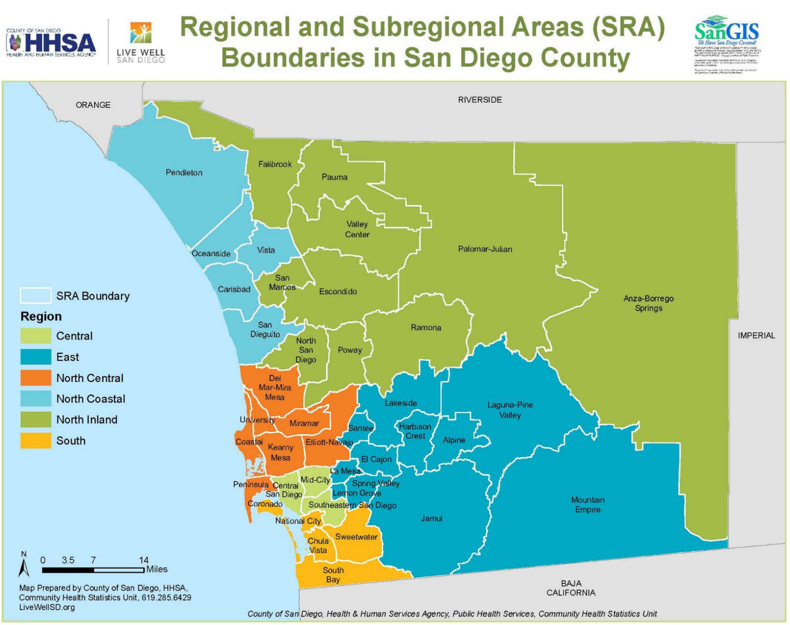

The following datasets were used in this analysis:

* *2017 San Diego County Demographics - Race and Ethnicity*
  + Ethnic makeup of San Diego’s neighborhoods, sourced from U.S. Census Bureau data and 2013-2017 American Community Survey 5-Year Estimates
  + Source: https://data.sandiegocounty.gov/Demographics/2017-San-Diego-County-Demographics-Race-and-Ethnic/cfnc-fcan
* *2015 San Diego County Demographics - County Population by Age and Gender*
  + Age and gender makeup of San Diego’s neighborhoods, sourced from U.S. Census Bureau data and 2011-2015 American Community Survey 5-Year Estimates
  + Source: <https://data.sandiegocounty.gov/Demographics/2015-San-Diego-County-Demographics-County-Populati/u5yb-6378>
* *2016 San Diego County Demographics - Number of Households by Household Income*
  + Number of San Diego households in each income level, sourced from U.S. Census Bureau data and 2012-2016 American Community Survey 5-Year Estimates
  + Source: <https://data.sandiegocounty.gov/Demographics/2016-San-Diego-County-Demographics-Number-of-House/ny52-s7nt>
* *2015 San Diego County Demographics - Vehicles and Transportation to Work*
  + Breakdown of methods that San Diego residents take to commute to work, sourced from U.S. Census Bureau data and 2011-2015 American Community Survey 5-Year Estimates
  + Source: https://data.sandiegocounty.gov/Demographics/2015-San-Diego-County-Demographics-Vehicles-and-Tr/mdp3-vn39

Geospatial data for the SRAs was obtained via the San Diego Open GIS Data Portal (<https://sdgis-sandag.opendata.arcgis.com/>), specifically from the dataset MSA_SRA (<https://sdgis-sandag.opendata.arcgis.com/datasets/msa-sra>) with assistance from the online virtual mapping application.

A GeoJSON for the SRA borders was obtained, via SANDAG’s API, from the dataset Subregional Areas (SRAs) (<https://sdgis-sandag.opendata.arcgis.com/datasets/subregional-areas-sras/geoservice>).

Venue data was obtained using the Foursquare API.

# **Methodology**

**Geospatial Data and Venues**

A pandas dataframe was created using the names and geographical coordinates of the San Diego’s neighborhoods.

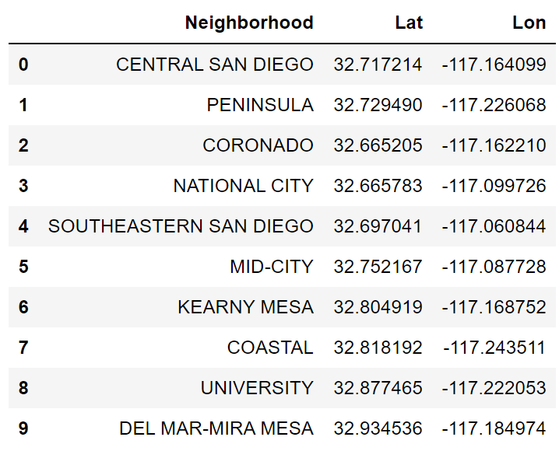

The coordinates for the City of San Diego were then obtained via geocoding. This analysis focused only on the major populated urban neighborhoods around the city center and along the coast, where the majority of the population resides. Neighborhoods in the surrounding county area consisting of primarily rural, sparsely populated land and mountains were excluded. The following SRAs were excluded from this analysis:

* Alpine
* Anza-Borrego Springs
* Fallbrook
* Harbison Crest
* Jamul
* Laguna-Pine Valley
* Lakeside
* Mountain Empire
* Palomar-Julian
* Pauma
* Pendleton
* Valley Center

The following map was generated using the geospatial data to visualize San Diego’s neighborhoods and their borders.

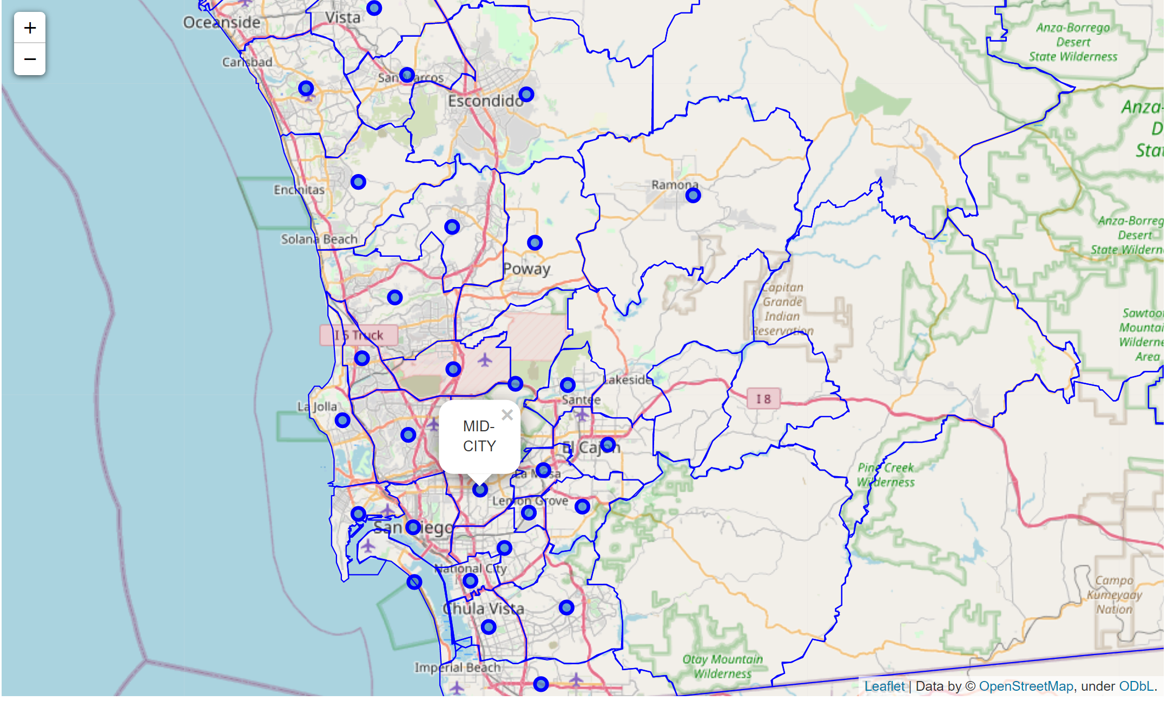

The Foursquare API was used to obtain the top 100 venues within a 3200m (~2 mile) radius of each neighborhood center – venue name, category, and geographic coordinates were obtained. The venue category data were transformed via one-hot encoding to determine the frequency of each venue category per neighborhood, thus identifying the top 10 most common venue categories in each neighborhood. Using this data, a KMeans clustering model was used to cluster the neighborhoods according to similarities in venue categories. The following map shows the clusters that were generated, labeled with different colored markers.

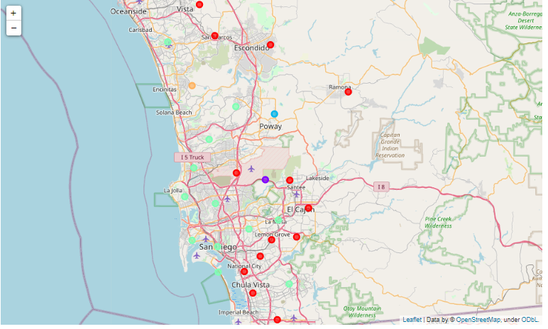

After examining the individual clusters in more detail, Mexican restaurants seemed to be very common in cluster 0, where they are the most common venue type in 11 of 14 neighborhoods.

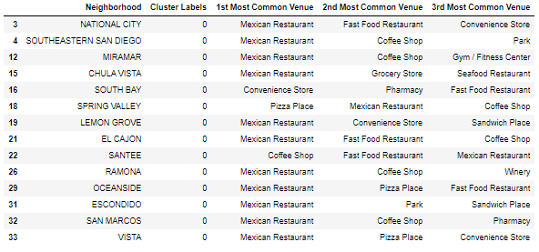

The number of Mexican restaurants in each neighborhood was then visualized to better understand the disparity between neighborhoods, represented in both chart and heat map format.

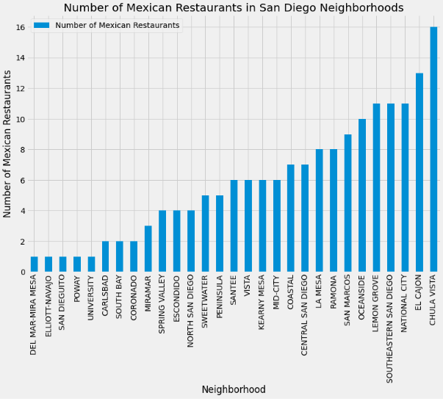

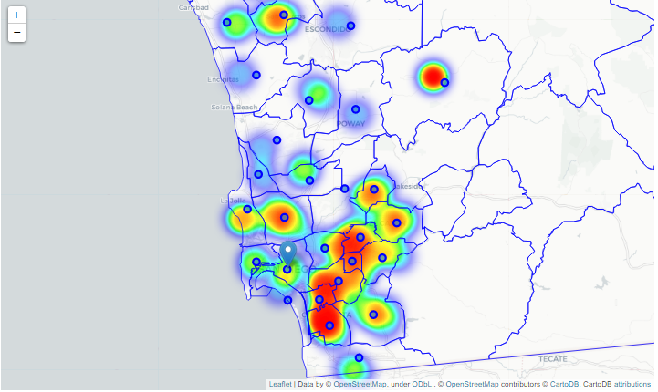

**Demographic Data**

***Ethnicity***

The breakdown of San Diego’s neighborhoods by ethnic makeup was explored using the Race and Ethnicity dataset from the City of San Diego. The dataset segments ethnic groups into Hispanic, White, Black, API (Asian/Pacific Islander, includes Hawaiian), AIAN (American Indian/Alaskan Native), and Other. First, the overall population of each neighborhood was visualized to gain a baseline understanding of how populated each neighborhood is.

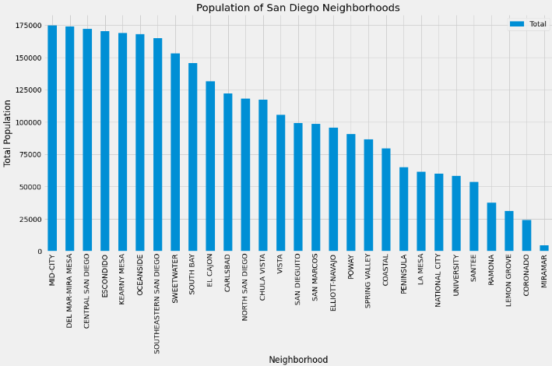

Total population of each neighborhood was then represented via a choropleth map.

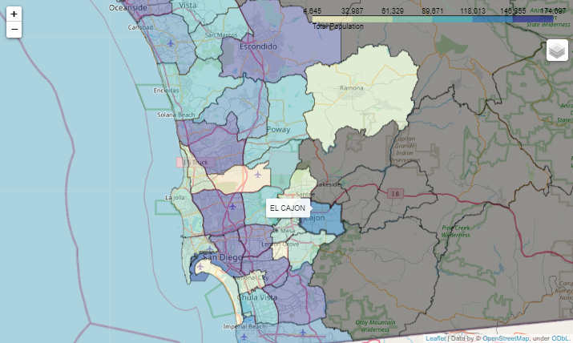

After determining the total population of each neighborhood, the ethnic breakdown for each was analyzed.

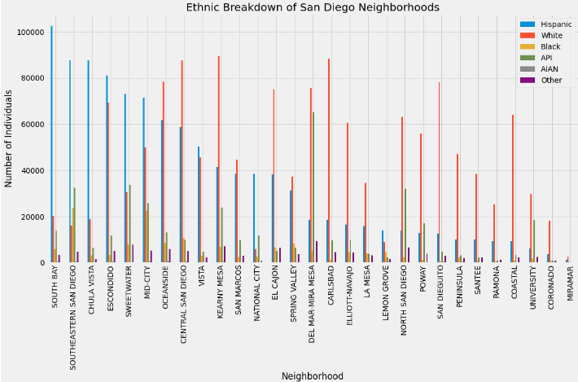

Due to the high number of Hispanic individuals in many of the neighborhoods, this population was further examined as a key target market. The ethnicity data was cleaned to focus on the Hispanic population, and a choropleth map was generated to illustrate Hispanic population levels around San Diego.

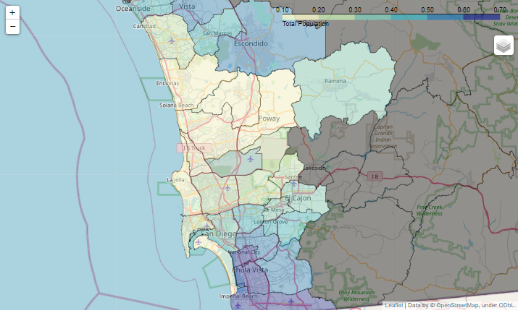

***Age***

The data from the Age and Gender dataset was analyzed similarly to the ethnicity data. The dataset breaks down each neighborhood’s population into age groups (0-4, 5-14, 15-24, 25-44, 45-64, and 65+). The dataset also breaks down each neighborhood by gender, but gender was disregarded for purposes of this analysis. This analysis focused on the age groups of 15-24 and 25-44, under the assumption these age groups have the highest propensity to eat out, from a convenience and a from a social standpoint. These age groups were combined into a singular 15-44 age group, and sorted in descending order.

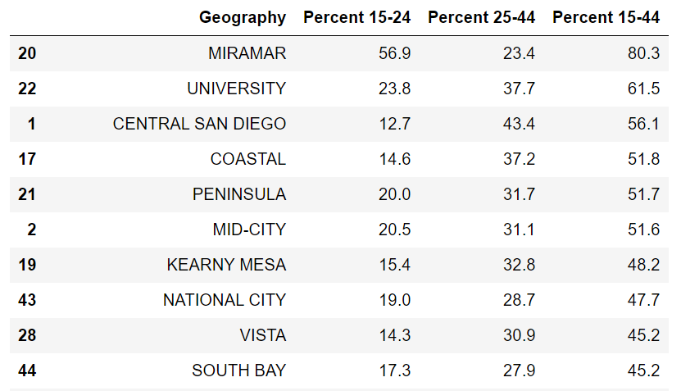

Miramar was noted as a clear outlier with >80% of the population aged 15-44, but as seen in the above section, its population is disproportionately smaller than the majority of other neighborhoods, so it was excluded from this section of the analysis. A choropleth map was generated to map the remaining San Diego neighborhoods by age.

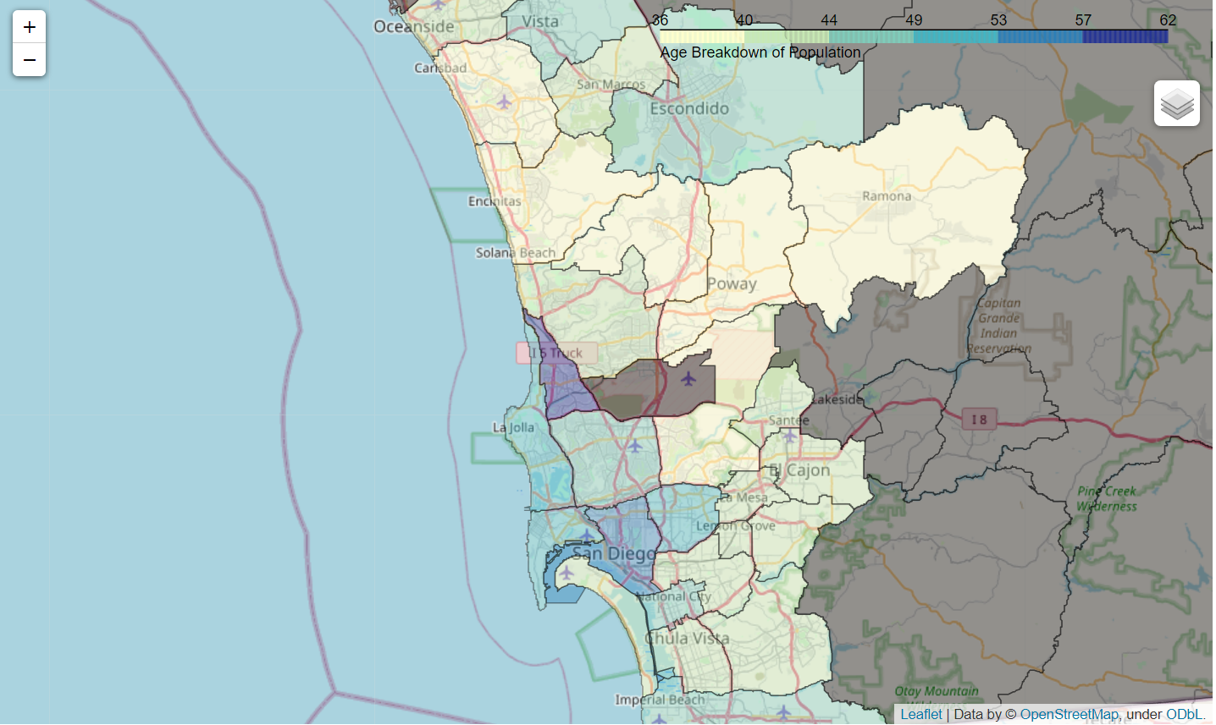

The University neighborhood, home of UC San Diego, a top U.S. university, and the surrounding coastal region where many students reside for inexpensive housing, are major hubs of people ages 15-44. The central San Diego neighborhood also has a high population of 15-44 year-old individuals, consisting of downtown and the surrounding areas with a large population of working professionals.

***Income***

Each neighborhood was then analyzed according to percentage of the population in different income levels, to determine high concentrations of higher-income residents and lower-income residents. This was considered another variable of interest when considering an optimal location for a new Mexican restaurant, as the strategic approach may vary according to the population demographics.

From the Income dataset, the extreme high and extreme low-income levels were of most interest, so the intermediate levels were disregarded for this analysis. Beginning with the low-income levels, a histogram was generated to get an idea of this breakdown.

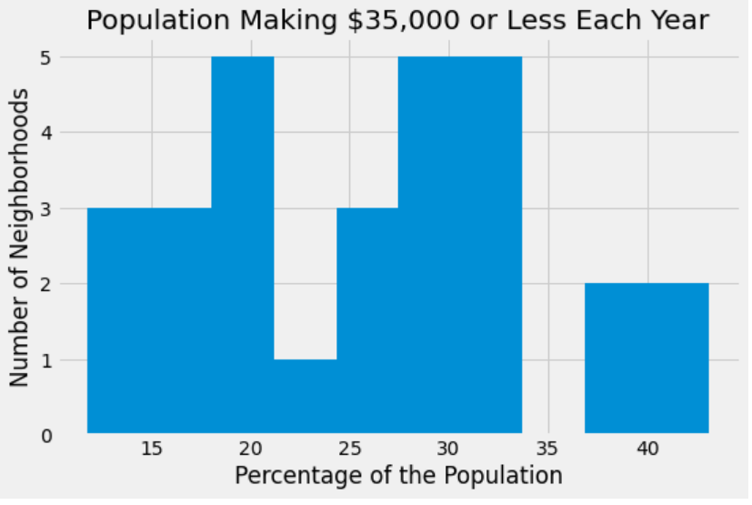

The neighborhoods were then ordered according to the percentage of the population making less than $35,000 annually, and a choropleth map was generated.

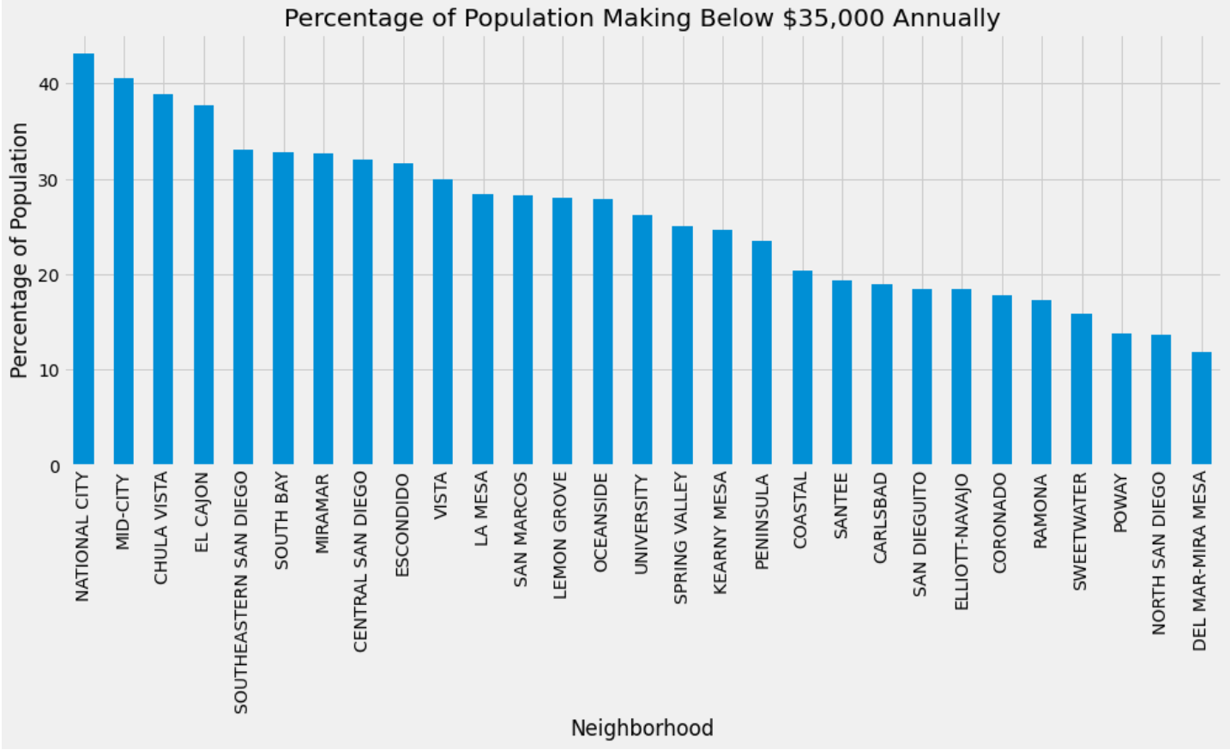

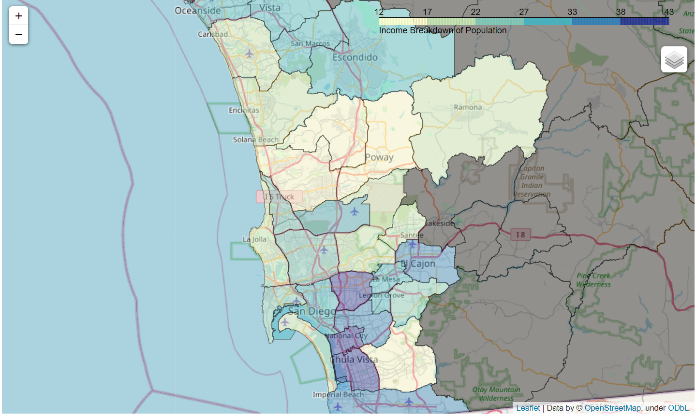

Following analysis of the low-income population, the high-income population was then analyzed following the same process, but for households making more than $100,000 annually. The resulting ordered bar chart and choropleth map are displayed below.

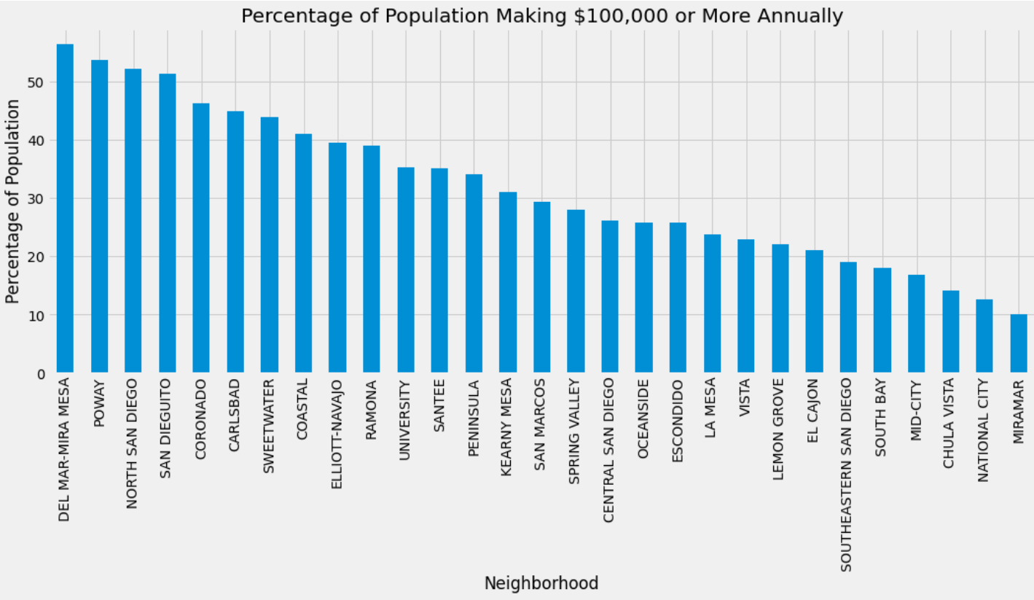

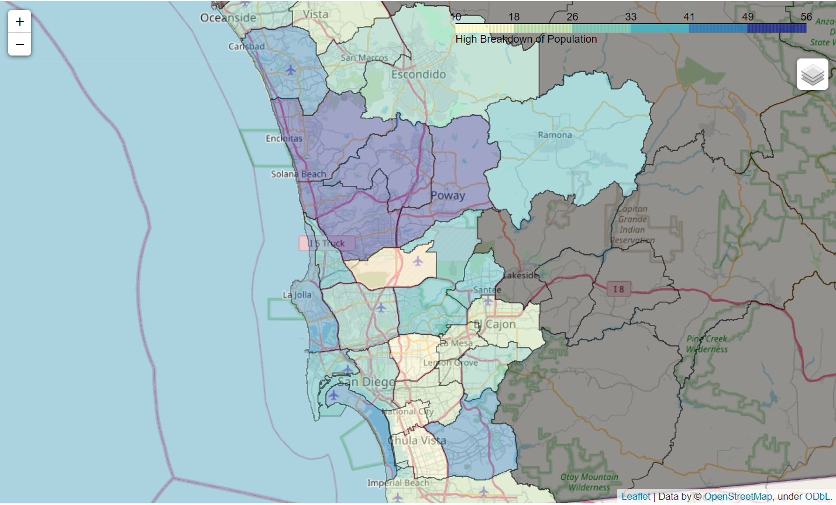

***Methodology of Commuting to Work***

In addition to ethnicity, age and income, the modality used to commute to work was also explored to determine any additional insights that may be of value to an aspiring restauranteur. In particular, the number of people who walk to work compared to driving or other methods of transportation was analyzed, as people who walk to work may be more likely to stop in to grab a bite to go or take a well-deserved rest with coworkers/friends after getting off work.

From the Vehicles and Transportation to Work dataset, the percentage of people who walk to work was analyzed for each neighborhood. Overall, a negligible percentage of people walk to work in almost all neighborhoods (<10%), but there may be potential value in the neighborhoods where >5% of people walk to work, especially if those neighborhoods are highly populated.

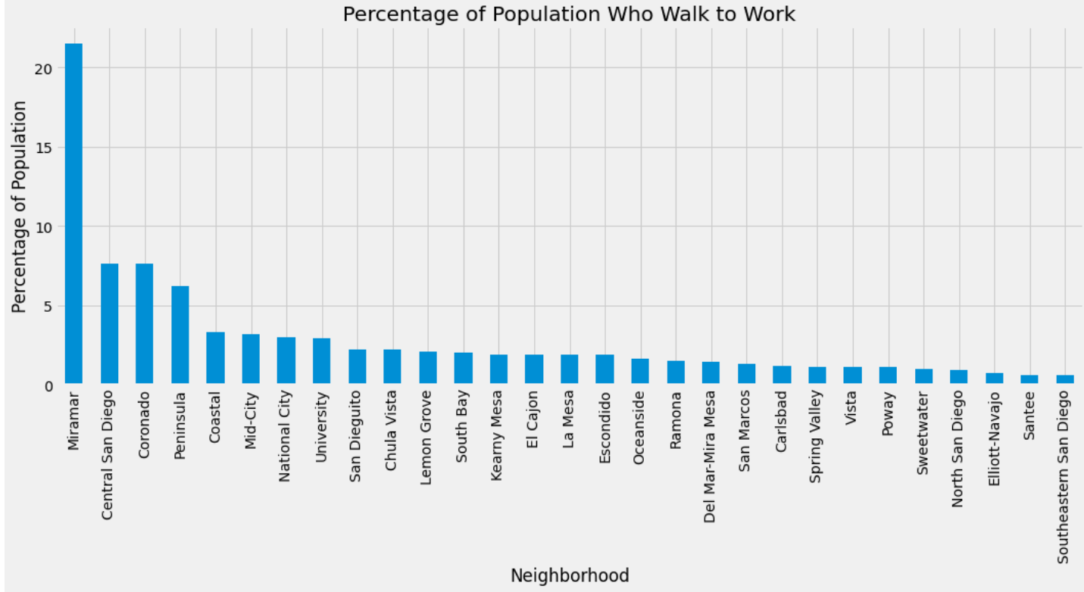

# **Results**

In cluster 0, Mexican restaurants were found to be the most common venue category in 11 of 14 neighborhoods in the cluster. In San Dieguito, University and Del Mar-Mira Mesa, there is only 1 Mexican restaurant in the immediate area, and 7 neighborhoods, including South Bay, North San Diego, Coronado and Spring Valley, have 4 or less.

The greatest proportion of Hispanic people in the city are found in the Southern and Southeastern neighborhoods in San Diego, namely South Bay, Chula Vista and National City, as well as Escondido and Vista. The neighborhoods of University and Central San Diego contain the highest percentage of people aged 15-44, excluding Miramar due to its disproportionate population size, but all neighborhoods are at least 35% comprised of people ages 15-44. The neighborhoods of National City, Mid-City, Chula Vista and El Cajon have the highest percentage of households making below USD $35,000 annually. Alternatively, the northern neighborhoods of Del Mar-Mira Mesa, Poway, North San Diego and San Dieguito have the highest percentage of households making above USD $100,000 annually. In terms of walkability, Miramar, Central San Diego, Coronado and Peninsula have the highest percentage of people who commute to work on foot, though <5% of the population walks to work in all but these 4 neighborhoods.

# **Discussion**

The neighborhoods were scored according to existing competition, percentage Hispanic population, percentage of people aged 15-44 and walkability, resulting in the following labeled choropleth map:

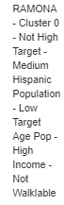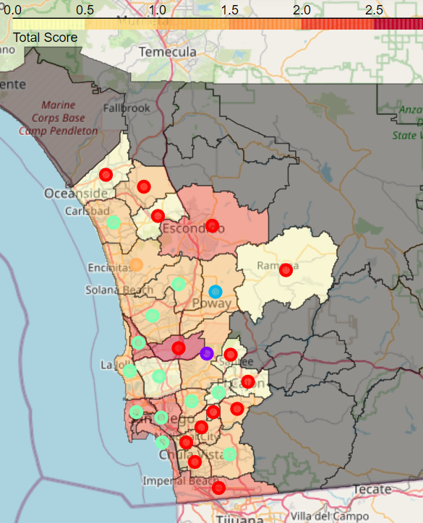

The darkest regions of the choropleth represent the lowest concentration of Mexican restaurants, and red cluster markers indicate cluster 0, which represent the most saturated markets. Potential neighborhoods of interest include Peninsula, Coronado, Central San Diego, and University, which have favorable combinations of target age group, little competition, Hispanic population and walkability. Of these, Coronado has the highest percentage of high-income households, while Central San Diego has the highest percentage of low-income households. A premium model may be appropriate in Coronado, whereas a fast-casual strategy may be more favorably received in the Central San Diego area. In University and Peninsula there is more flexibility in which approach to take, as the population falls somewhere in the middle of the extremes.

# **Conclusion**

This research was conducted to analyze the landscape around San Diego for an aspiring entrepreneur who is looking to open a new Mexican restaurant somewhere in the city. San Diego is large and diverse with a wide variety of places to go and things to do. If someone wishes to open a new Mexican restaurant within the city, there are several avenues they can take to segment and analyze the various neighborhoods to identify likely candidates. This analysis leveraged data on ethnicity, age, income, and method of commuting to work to segment the areas of the city, and venue data to cluster the neighborhoods according to commonalities in venue type.

A limitation of this analysis is that the subregional areas used vary greatly in size and can be broken down further still, but this data was unavailable during the time this analysis was conducted. Appropriateness of assumptions may be another limitation, as there is uncertainty around these assumptions – additional background research, including potential consumer preference data, would be relevant and something to further explore in future analyses.